Technical Data Sheet

Product Name：PLCC-5050 High Bright Red SMD Chip LED

Part Number： HT61-2301SURSURSURC(S)

Customer：

Customer PN：

Version No.： A.2

Date： 2009.01.01

Customer Approval

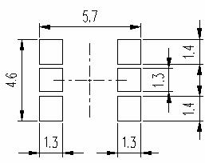

1、Features

● Package ( L/W/H ) : 5.4 × 5.0 × 1.6 mm
● Color : Ultra Bright Red
● Lens: Water Clear Flat Mold
● EIA STD Package
● Meet ROHS, Green Product
● Compatible With SMT Automatic Equipment
● Compatible With Infrared Reflow Solder And Wave Solder Process

2、 Package Profile & Soldering PAD Suggested

+ ①

+ ③

+ ⑤

MARK

Φ3.3

② -

④ -

⑥ -

+ ①

+ ③

+ ⑤

Polatity

② -

④ -

⑥ -

Notes: 1. All dimensions are in millimeters ;
2. Tolerance is ± 0.10 mm unless otherwise noted.

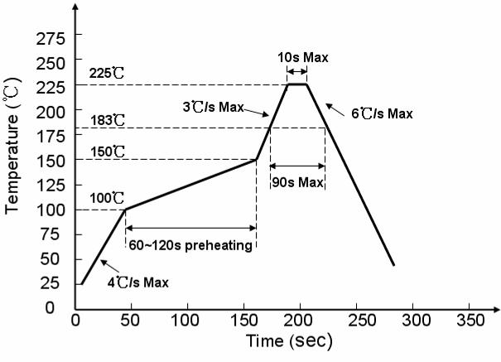
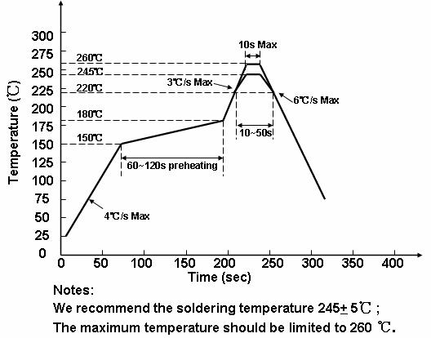

3、 Soldering Profile Suggested

3.1、For Lead Solder

3.2、For Lead Free Solder

4． Absolute Maximum Ratings At Ta=25℃

Parameter Symbol

R1

Rating

70

Unit

Power Dissipation

Peak Forward Current
(1/10 Duty Cycle, 0.1ms Pulse Width)

DC Forward Current

Reverse Voltage

Operating Temperature Range
Pd

I_{FP}

IF

VR

Topr
R2
R3
R1
R2
R3
R1
R2
R3
R1
R2
R3
70
70
70
70
70
30
30
30
5
5
5

-30°C ~ + 85°C
mW

mA

mA

V

Storage Temperature Range

Soldering Condition
Tstg

Tsol
-40°C ~ + 90°C

Reflow soldering : 260°C For 5 Seconds
Hand soldering: 300°C For 3 Seconds

5、 Electrical Optical Characteristics At Ta=25℃

Parameter Symbol Color Min. Typ. Max.

Unit

Test Condition

Luminous Intensity

Dominant Wavelength

Peak Wavelength

Spectral Line Half-Width

Forward Voltage

IV

λd

λp

Δλ

VF

R1
R2
R3
R1
R2
R3
R1
R2
R3
R1
R2
R3
R1
R2
R3

---
---
---
---
---
---
---
---
---
---
---
---
1.8
1.8
1.8

280
280
280
624
624
624
630
630
630
20
20
20
---
---
---

---
---
---
---
---
---
---
---
---
---
---
---
2.6
2.6
2.6

mcd

nm

nm

nm

V

IF = 20mA

IF=20mA

IF=20mA

IF=20mA

IF=20mA

R1 --- --- 10
Reverse Current IR R2 --- --- 10 uA

VR=5V

Viewing Angle

2θ1/2
R3
---
---
---
---
120
10
---

deg

IF = 20mA

Notes: 1. Luminous intensity is measured with a light sensor and filter combination that approximates the
CIE eye-response curve.

2. θ1/2 is the off-axis angle at which the luminous intensity is half the axial luminous intensity.
3. The dominant wavelength, λd is derived from the CIE chromaticity diagram and represents the
single wavelength which defines the color of the device.

